1. **ABSTRACT**

“Student Information System” (SIS) is a web-based application for students, faculty and parents who want to get and retrieve student’s whole information instantly via internet. The major benefit of this web portal is to store the student information at one place (like SERVER) and it can be accessed via online interaction. The SIS web portal is to replace old and traditional file (paper work) storing process. Instead of tedious paper work, students will be able to submit required information electronically, and the departments will be able to evaluate the submissions with a much quicker turnaround. The SIS consists of two main modules student and faculty. The students can view their attendance and marks in internal examinations. The faculty can update the marks and attendance.

**2. INTRODUCTION**

Student Information system is a portal which thinks students as the main target users and provides so many useful services to students at a single place and through a single interface but in customized form. It is not only useful to students of the college but also staff members of the college. System objective is of being useful in significant way by providing most basic and most essential functionalities and features to its users in efficient and effective manner.

“Portal” is a web system that provides functions and features to authenticate and identify the users and provide them with an easy, intuitive, personalized and user-customizable wed interface for facilitating access to information and services that are of primary relevance and interests to the users.

**Problem Statement:**

Students face difficult in accessing various types of academic information and its difficult for faculty to maintain huge amount of paper work which is difficult to store and search in order to retrieve a student information.

**Existing System:**

The main problem that with manual information storage and retrieval is its very time consuming and complexity because as number of batches pass by huge amount of student information is to be maintained which can be very cumbersome process and information can only be retrieved by consulting faculty in institution.

**Proposed System:**

The Student Information System provides a platform for both faculty and students in efficient storage and retrieval of information through web which can be accessible by any time and place which in turn can save a huge amount of time and manual work.

**3. REQUIREMENTS**

**3.1 Hardware Requirements**

* Processor: Intel Dual Core, 32bit.
* RAM : 1 GB.
* Hard Disk : min.40GB.

**3.2 Software Requirements**

* Operating System: windows 7/ 8/ 10.
* Web Server: Apache Tomcat 7.0
* Database: Oracle 10g.
* Text editors: Notepad ++.
* Languages: HTML, CSS, JSP.

**4. CREATING AND RUNNING WEB APPLICATIONS**

**4.1 HTML WEB PAGES:**

**What is HTML**

HTML is the standard markup language for creating Web pages.

* HTML stands for Hyper Text Markup Language
* HTML describes the structure of Web pages using markup
* HTML elements are the building blocks of HTML pages
* HTML elements are represented by tags
* HTML tags label pieces of content such as "heading", "paragraph", "table", and so on
* Browsers do not display the HTML tags, but use them to render the content of the page

**Write HTML Using Notepad**

Web pages can be created and modified by using professional HTML editors.

However, for learning HTML we recommend a simple text editor like Notepad (PC)

We believe using a simple text editor is a good way to learn HTML.

Follow the four steps below to create your first web page with Notepad **.**

**Step 1: Open Notepad (PC)**

Windows 8 or later:

Open the Start Screen (the window symbol at the bottom left on your screen). Type Notepad.

Windows 7 or earlier:

Open Start > Programs > Accessories > Notepad

**Step 2: Write Some HTML**

Write or copy some HTML into Notepad.

<!DOCTYPE html>  
<html>  
<body>  
<h1>My First Heading</h1>  
<p>My first paragraph.</p>  
</body>  
</html>

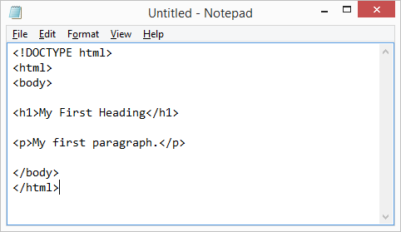

**Step 3: Save the HTML Page**

Save the file on your computer. Select **File > Save as** in the Notepad menu.

Name the file **"index.htm"** and set the encoding to **UTF-8** (which is the preferred encoding for HTML files).

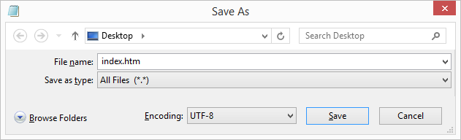

**Step 4: View the HTML Page in Your Browser**

Open the saved HTML file in your favorite browser (double click on the file, or right-click - and choose "Open with").

The result will look much like this:

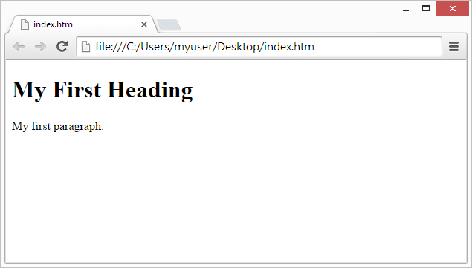

**4.2 JSP PAGE :**

**Step 1: Create a Project Directory**

Create a directory with the name of the Project (ARS in our case), in the “webapps” directory of the “Apache Tomcat” folder.

**Step 2: Copy the WEB-INF from ROOT directory to Project Directory**

Copy WEB-INF: Program Files > apache-tomcat-X >webapps> ROOT > WEB-INF

Paste into the Project Directory which is previously created.

**Step 3: Open any Text Editor**

Write the JSP code and save the file with an extension “.jsp” and to a UTF-8 encoding, in the Project Directory.

**Step 4: Run the JSP Page on the Browser**

Start the Tomcat Server and type the following link in the browser:

http://localhost:8084/WT/home.html

**4.3 TOMCAT SERVER:**

**Step 1:** Open the CMD as an Administrator

**Step 2:** Type the following commands:

* cd\
* cd “Program Files\apache-tomcat-7.0.85\bin”
* startup

**Step 3:** Open the browser and check for the Apache Tomcat Server home page by typing the following link:

<http://localhost:8084>

**Step 4:** To stop the server press “Ctrl+C” in the CMD.

**4.4 RUN THE PROJECT:**

Start the Tomact Server and type the following:

http://localhost:8084/SIDS/index.jsp

**5. IMPLEMENTATION**

**5.1 MODULES:**

**5.1.1 Module-1: Home Page**

This is the main page of our website which is the gateway to the other modules. This page contains the details of the website and from this page the user can signup or login into his account.

**5.1.2 Module-2: Signup Page**

Using this module a user can register in the website as a student. The user can enter his details and can generate his own password using this module. For a user to enter into their account he/she initially has to create their account using this page.

**5.1.3 Module-3: Student Page**

In this module a student can enter into his/her account. Once entered into the account the student can view the attendance and marks secured.

**5.1.4 Module-4: Faculty page**

This is the admin/faculty page in which faculty acts as admin. The faculty as an admin can enter student’s marks and mark their attendance. Also the faculty can view the attendance of the students.

**5.2 SOURCE CODE:**

**5.2.1 index.jsp:**

<!DOCTYPE html>

<%

String userid=(String)session.getAttribute("userid");

if(userid!=null) {

session.setAttribute("userid",null);

}

%>

<html lang="en" >

<head>

<title>Student Information Database System</title>

<link rel="stylesheet" href="css.css">

</head>

<body background="7.jpg"> <br> <br> <br> <br>

<marquee><h1><b>Student Information Portal</marquee> </h1> </b> <br> <br> <br>

<center>

<button class="button button1" onclick="document.location.href='student_signup.jsp';"> <h4> Sign Up </h4> </button>

&nbsp &nbsp

<button class="button button1" onclick="document.location.href='about.html';"> <h4> About </h4> </button>

<br> <br>

<button class="button button1" onclick="document.location.href='student_login_page.jsp';">

<h4>Student Login</h4>

</button>

<br> <br>

<button class="button button1" onclick="document.location.href='faculty_login_page.jsp';">

<h4> Faculty Login </h4> </button> <br> <br> <br>

</center>

<h2 class="white"> ABOUT </h2> <br>

<h3><p>Student Information System (SIS) is a web-based application for students, faculty and parents who want to get and retrieve student whole information instantly via internet. The major benefit of this web portal is to store the student information at one place (like SERVER) and it can be accessed via online interaction. The SIS web portal is to replace old and traditional file (paper work) storing process. Instead of tedious paper work, students will be able to submit required information electronically, and the departments will be able to evaluate the submissions with a much quicker turnaround. The SIS consists of two main modules student and faculty. The students can view their attendance and marks in internal examinations. The faculty can update the marks and attendance.</p></h3>

</body>

</html>

**5.2.2 About.html:**

<html>

<head>

<title> about </title>

<style>

.silver {

color: silver;

}

.white {

color: white;

}

</style>

</head>

<body background="6.jpeg">

<h2><p>INTRODUCTION</p></h2>

<h3><p class="white">Student Information system is a portal which thinks students as the main target users and provides so many useful services to students at a single place and through a single interface but in customized form. It is not only useful to students of the college but also staff members of the college. System objective is of being useful in significant way by providing most basic and most essential functionalities and features to its users in efficient and effective manner. </p>

<p class="white">Portal is a web system that provides functions and features to authenticate and identify the users and provide them with an easy, intuitive, personalized and user-customizable wed interface for facilitating access to information and services that are of primary relevance and interests to the users. </p>

</h3>

<h2><p >Problem Statement</p>

</h2>

<h3><p class="white">Students face difficult in accessing various types of academic information and its difficult for faculty to maintain huge amount of paper work which is difficult to store and search in order to retrieve a student information.</p></h3>

<h2><p >Current System</p>

</h2>

<h3><p class="white">The main problem that with manual information storage and retrieval is its very time consuming and complexity because as number of batches pass by huge amount of student information is to be maintained which can be very cumbersome process and information can only be retrieved by consulting faculty in institution.</p>

</h3>

<h2><p >Proposed System</p>

</h2>

<h3><p class="white">The Student Information System provides a platform for both faculty and students in efficient storage and retrieval of information through web which can be accessible by any time and place which in turn can save a huge amount of time and manual work.</p>

</h3>

**5.2.3 Student_signup.jsp:**

<!DOCTYPE html>

<html lang="en">

<head>

<title>Student Information Database System</title>

<link rel="stylesheet" href="css.css">

</head>

<body background="2.jpg">

<form id="reg-form" action="sign_up_validate.jsp"> <br> <br>

<marquee> <h1> <b> Student Information Portal </marquee> </h1> </b> <br>

<center> <b> <h2> STUDENT SIGN UP PAGE </h2> </b> <br> <br> </center>

<input id="first_name" type="text" maxlength="25" required name="first_name">

<label for="first_name">First Name</label>

<br> <br>

<input id="last_name" type="text" maxlength="23" required name="last_name">

<label for="last_name">Last Name</label>

<br> <br>

<input id="roll" type="number" required name="roll">

<label for="Registration Number">Registration Number</label>

<br> <br>

<input id="password" type="password" minlength="5" maxlength="19" required name="pass1">

<label for="password" >Password</label>

<br> <br>

<input id="password" type="password" minlength="5" maxlength="19" required name="pass2">

<label for="Re-password">Re-enter Password</label>

<br> <br>

<button class="button button1" type="submit" name="action"> <h4> Register </h4> </button>

</form>

<%

String status=(String)session.getAttribute("sign_up");

if(status!=null && status.equals("pass_err")) {

%>

<script type="text/javascript">

window.alert("password and re-enter password do not match");

</script>

<%

session.setAttribute("sign_up",null);

}

else if(status!=null && status.equals("already_exsists")) {

%>

<script type="text/javascript">

window.alert("Account already exsists");

</script>

<%

session.setAttribute("sign_up",null);

}

%>

</body>

</html>

**5.2.4 Sign_up_validate.jsp:**

<!DOCTYPE html>

<html>

<head>

<title>Student Information Database System</title>

</head>

<body bgcolor=#5DADE2>

<%@page import="java.sql.*" %>

<%

String first_name=request.getParameter("first_name");

String last_name=request.getParameter("last_name");

String roll=request.getParameter("roll");

String password=request.getParameter("pass1"),name=null;

String password2=request.getParameter("pass2");

int flag=1;

if(!(password.equals(password2)))

{

response.sendRedirect("student_signup.jsp");

session.setAttribute("sign_up","pass_err");

flag=0;

}

if(flag==1) {

Class.forName("oracle.jdbc.OracleDriver");

Connection con=DriverManager.getConnection("jdbc:oracle:thin:@localhost:1521:xe","system","vikas");

Statement st=con.createStatement();

ResultSet rs=st.executeQuery("select name from sip_student where sid='"+roll+"' ");

while(rs.next()) {

name=rs.getString(1);

}

if(name==null){

name=first_name+" "+last_name;

st.executeQuery("insert into sip_student values('"+roll+"','"+name+"','"+password+"' )");

response.sendRedirect("student_login_page.jsp");

}

else{

response.sendRedirect("student_signup.jsp");

session.setAttribute("sign_up","already_exsists");

} }

%>

</body>

</html>

**5.2.5 Student_login_page.jsp:**

<!DOCTYPE html>

<html lang="en">

<head>

<title>Student Information Database System</title>

<link rel="stylesheet" href="css.css">

</head>

<body background="3.jpg">

<center>

<form method="post" action="login_validate.jsp"> <br> <br>

<center> <b> <h1> Student Login </h1> </b> <br> </center>

<input type="number" name="roll" placeholder="Registration Number"> <br> <br>

<input type="password" name="pass" placeholder="Password"> <br> <br>

<h3> <input type="submit" name="login_submit" value="Login" class="button button1"> </h3> </button> <br>

<a href="student_signup.jsp"> Create your Account </a>

</form>

</center>

<%

String userid=(String)session.getAttribute("userid");

if(userid!=null && userid.equals("error")) {

%>

<script type="text/javascript">

window.alert("Invalid Registration number or password");

</script>

<%

session.setAttribute("userid",null);

}

else if(userid!=null && userid.equals("login_first")) {

%>

<script type="text/javascript">

window.alert("Please Login First!!!");

</script>

<%

session.setAttribute("userid",null);

}

else if(userid!=null) {

session.setAttribute("userid",null);

}

%>

</body>

</html>

**5.2.6 Login_validate.jsp:**

<!DOCTYPE html>

<html>

<head>

<title>Student Information Database System</title>

</head>

<body bgcolor=#5DADE2>

<%@page import="java.sql.*" %>

<%

String roll=request.getParameter("roll");

String password=request.getParameter("pass"),tab_pass=null;

Class.forName("oracle.jdbc.OracleDriver");

Connection con=DriverManager.getConnection("jdbc:oracle:thin:@localhost:1521:xe","system","vikas");

Statement st=con.createStatement();

ResultSet rs=st.executeQuery("select password from sip_student where sid='"+roll+"' ");

while(rs.next())

tab_pass=rs.getString(1);

if(tab_pass!=null && tab_pass.equals(password)) {

session.setAttribute("userid",roll);

response.sendRedirect("student.jsp");

}

else {

session.setAttribute("userid","error");

response.sendRedirect("student_login_page.jsp");

}

%>

</body>

</html>

**5.2.7 Student.jsp:**

<!DOCTYPE html>

<html lang="en">

<%

String userid=(String)session.getAttribute("userid");

if(userid==null) {

response.sendRedirect("student_login_page.jsp");

session.setAttribute("userid","login_first");

}

%>

<head>

<title> Student Information Database System </title>

<link rel="stylesheet" href="css.css">

</head>

<body background="3.jpg"> <br> <br>

<center> <h1> Student Home Page </h1> </center>

<header id="header-1">

<a href="#"> <%= userid %> </a>

</header> <br>

<center>

<button class="button button1" onclick="document.location.href='student_marks_info.jsp';">

<h3> Student Marks </h3> </button> <br> <br>

<button class="button button1" onclick="document.location.href='student_attendance_info.jsp';">

<h3> Student Attendance </h3> </button>

<br> <br> <br>

<a href="index.jsp"> Log out </a>

</center>

</body>

</html>

**5.2.8 Student_marks_info.jsp:**

<!DOCTYPE html>

<%

String userid=(String)session.getAttribute("userid");

if(userid==null) {

response.sendRedirect("student_login_page.jsp");

session.setAttribute("userid","login_first");

}

%>

<head>

<title>Student Information Database System</title>

<link rel="stylesheet" href="css.css">

</head>

<body background="5.jpg">

<center><h2>Student Marks</h2></center>

<header id="header-1" >

<a href="#" class="red"> <%= userid %> <i> </i> </a> <br> <br>

<a href="index.jsp" class="white">Log out</a>

</header>

<form action="student_marks.jsp" method="POST" id="test_info_insert">

<center>

<h5> Branch </h5>

<select name="marks_show_branch" form="test_info_insert" class="button button1">

<option>CSE</option>

<option>ECE</option>

<option>MECH</option>

<option>CIVIL</option>

</select>

<h5>semester</h5>

<select name="marks_show_sem" form="test_info_insert" class="button button1">

<option value="1">sem1</option>

<option value="2">sem2</option>

<option value="3">sem3</option>

<option value="4">sem4</option>

<option value="5">sem5</option>

<option value="6">sem6</option>

<option value="7">sem7</option>

</select>

<h5>Internal </h5>

<select name="marks_show_internal" form="test_info_insert" class="button button1">

<option value="1">Internal 1</option>

<option value="2">Internal 2</option>

<option value="3">Internal 3</option>

</select>

<h5>Date of Conduct</h5>

<input type="date" name="marks_show_date" required="" class="button button1">

<br>

<input type="hidden" name="marks_show_roll" value=<%=userid%> >

<br>

<input type="submit" value="submit" style="border-radius:5px;" class="button button1">

<br><br>

</form>

<a href="student.jsp" >Back to Home Page</a><br>

</center>

</body>

</html>

**5.2.9 Student_attendance_info.jsp:**

<!DOCTYPE html>

<%

String userid=(String)session.getAttribute("userid");

String batch="2016";

if(userid==null){

response.sendRedirect("sids/student_login_page.jsp");

session.setAttribute("userid","login_first");

}

else {

int one=userid.charAt(1)-'0';

int two=userid.charAt(2)-'0';

batch=Integer.toString(2000+((one*10)+two));

}

%>

<head>

<title>Student Information Database System</title>

<link rel="stylesheet" href="css.css">

</head>

<body background="5.jpg">

<center><b><h2>Student Attendance</h2></b></center>

<header id="header-1" >

<a href="#" class="red"><%= userid %> <i></i></a><br><br>

<a href="index.jsp" class="white">Log out</a>

</header>

<form id="cls_detail" action="student_attendance.jsp" method="post" data-abide="">

<center>

<h5> Branch </h5>

<select name="show_atten_branch" form="cls_detail" class="button button1">

<option>CSE</option>

<option>ECE</option>

<option>MECH</option>

<option>CIVIL</option>

</select>

<h5>semester</h5>

<select name="show_atten_sem" form="cls_detail" class="button button1">

<option value="1">sem1</option>

<option value="2">sem2</option>

<option value="3">sem3</option>

<option value="4">sem4</option>

<option value="5">sem5</option>

<option value="6">sem6</option>

<option value="7">sem7</option>

</select>

<input type="hidden" name="show_atten_batch" value=<%=batch%> >

<input type="hidden" name="show_atten_roll" value=<%=userid%> >

<br><br>

<input type="submit" value="submit" style="border-radius:5px;" class="button button1"><br><br>

<a href="student.jsp" >Back to Home Page</a>

</center>

</form>

</body>

</html>

**5.2.10 faculty_login_page.jsp:**

<!DOCTYPE html>

<html lang="en">

<head>

<title>Student Information Database System</title>

<link rel="stylesheet" href="css.css">

</head>

<body background="2.jpg"> <br> <br>

<marquee><h1><b>Student Information Portal</marquee> </h1> </b> <br> <br> <br>

<center> <b> <h1> Faculty Login </h1> </b> </center>

<form action="facl_login_validate.jsp" method="post"> <br> <br>

<center>

<input type="number" name="fid" placeholder="Faculty ID">

<br> <br>

<input type="password" name="pass" placeholder="Password">

<br> <br>

<h3> <input type="submit" name="login_submit" value="Login" class="button button1"> </h3> </button> <br>

<a href="index.jsp"> Back to home </a>

</center>

</form>

<%

String userid=(String)session.getAttribute("userid");

if(userid!=null && userid.equals("error")) {

%>

<script type="text/javascript">

window.alert("Invalid Username or password");

</script>

<%

session.setAttribute("userid",null);

}

else if(userid!=null && userid.equals("login_first")) {

%>

<script type="text/javascript">

window.alert("Please Login First!!!");

</script>

<%

session.setAttribute("userid",null);

}

else if(userid!=null) {

session.setAttribute("userid",null);

}

%>

</body>

</html>

**5.2.11 facl_login_validate.jsp:**

<!DOCTYPE html>

<html>

<head>

<title>Student Information Database System</title>

</head>

<body bgcolor=#F0B27A>

<%@page import="java.sql.*" %>

<%

String user=request.getParameter("fid");

String password=request.getParameter("pass"),tab_pass=null;

Class.forName("oracle.jdbc.OracleDriver");

Connection con=DriverManager.getConnection("jdbc:oracle:thin:@localhost:1521:xe","system","vikas");

Statement st=con.createStatement();

ResultSet rs=st.executeQuery("select password from sip_faculty where fid='"+user+"' ");

while(rs.next())

tab_pass=rs.getString(1);

if(tab_pass!=null && tab_pass.equals(password)) {

session.setAttribute("userid",user);

response.sendRedirect("faculty.jsp");

}

else {

session.setAttribute("userid","error");

response.sendRedirect("faculty_login_page.jsp");

}

%>

</body>

</html>

**5.2.12 faculty.jsp:**

<!DOCTYPE html>

<html>

<%

String userid=(String)session.getAttribute("userid");

if(userid==null) {

response.sendRedirect("faculty_login_page.jsp");

session.setAttribute("userid","login_first");

}

%>

<head>

<title>Student Information Databse System</title>

<link rel="stylesheet" href="css.css">

</head>

<body background="4.jpg>

<center><br><h2 style="padding-left:30px;">Faculty Home Page</h2></br></center>

<header id="header-1">

<a href="#"><%= userid%> </a>

<a href="index.jsp">Log out</a>

</header>

<center>

<div style="border-radius:5px;">

<div id="login">

<div style="border-radius:5px;" onclick="document.location.href='marks_entry.jsp';">

<button class="button button1"> <h3>Enter the Marks</h3> </button>

</div><br>

<div style="border-radius:5px;" onclick="document.location.href='class_details.jsp';">

<button class="button button1"> <h3>Enter the Attendance</h3> </button>

</div><br><br><br>

<button onclick="document.location.href='disp_att.jsp';" class="button button1">View Student Attendance </button><br>

<button onclick="document.location.href='disp_marks.jsp';" class="button button1">View Student Marks </button>

</div>

<br /><br />

</div></center>

</body>

</html>

**5.2.13 marks_entry.jsp:**

<!DOCTYPE html>

<%

String userid=(String)session.getAttribute("userid");

if(userid==null) {

response.sendRedirect("faculty_login_page.jsp");

session.setAttribute("userid","login_first");

}

%>

<html>

<head>

<title>Student Information Database System</title>

</head>

<body bgcolor=#A9CCE3>

<header id="header-1" >

<a href="#"><%= userid%> <i></i></a>

<li>

<a href="index.jsp">Log out</a>

</li>

</header>

<div>

<form action="test_info.jsp" method="POST" id="test_info_insert"><center>

<div>

<div>

<h5>Branch</h5>

<select class="form-control" name="marks_insert_branch" form="test_info_insert">

<option>CSE</option>

<option>ECE</option>

<option>MECH</option>

<option>CIVIL</option>

</select>

</div>

<div>

<h5>semester</h5>

<select name="marks_insert_sem" form="test_info_insert">

<option value="1">sem1</option>

<option value="2">sem2</option>

<option value="3">sem3</option>

<option value="4">sem4</option>

<option value="5">sem5</option>

<option value="6">sem6</option>

<option value="7">sem7</option>

</select>

</div>

<div>

<h5>Batch</h5>

<input type="number" placeholder="eg:2015" name="marks_insert_batch" required="">

</div>

<div>

<h5>Internal </h5>

<select name="marks_insert_internal" form="test_info_insert">

<option value="1">Internal 1</option>

<option value="2">Internal 2</option>

<option value="3">Internal 3</option>

</select>

</div>

<div>

<h5>Date of Conduct</h5>

<input type="date" name="marks_insert_date" required="">

</div>

<div>

<h5>Test marks</h5>

<input type="number" name="tot_marks" required="">

</div>

</div>

<div>

<a href="faculty.jsp" >Back to Home Page</a>

<input type="submit" value="submit" style="border-radius:5px;font-size:1rem;">

</div>

</form></center>

</div>

</body>

</html>

**5.2.14 class_details.jsp:**

<!DOCTYPE html>

<%

String userid=(String)session.getAttribute("userid");

if(userid==null) {

response.sendRedirect("faculty_login_page.jsp");

session.setAttribute("userid","login_first");

}

%>

<html >

<head>

<title>Student Information Database System</title>

</head>

<body bgcolor=#17A589>

<header id="header-1">

<nav>

<div><div>

<ul>

<li>

<a href="#"><%= userid%> </a>

<ul>

<li>

<a href="index.jsp">Log out</a>

</li></ul>

</li><li></li></ul>

</div>

</div>

</nav>

</header>

<div>

<form id="cls_detail" action="enter_attendance.jsp" method="post" data-abide="">

<div>

<div>

<h5>Branch</h5>

<select name="class_detail_branch" form="cls_detail" style="font-size:1.2rem;">

<option>CSE</option>

<option>ECE</option>

<option>MECH</option>

<option>CIVIL</option>

</select>

</div>

<div>

<h5>semester</h5>

<select name="class_detail_sem" form="cls_detail" style="font-size:1.2rem;">

<option value="1">sem1</option>

<option value="2">sem2</option>

<option value="3">sem3</option>

<option value="4">sem4</option>

<option value="5">sem5</option>

<option value="6">sem6</option>

<option value="7">sem7</option>

</select>

</div>

<div>

<h5>Batch</h5>

<input type="number" placeholder="eg:2016" name="class_detail_batch" required="" pattern="number" style="font-size:1.2rem;">

<span>Field is required.</span>

</div>

<div>

<label>

<h5 style="color:black;">class strength*</h5>

<input type="number" name="class_detail_strength" required="" pattern="number" style="font-size:1.2rem;"/>

<span class="form-error">Field is required.</span>

</label>

</div>

<div>

<h5>total classes per day</h5>

<input type="number" required="" name="class_detail_clss" style="font-size:1.2rem;"/>

<span>Field is required.</span>

</div>

</div>

<div>

<a href="faculty.jsp" style="border-radius: 3px;

margin-right: 70px;

margin-top: 15px;

font-size:1.2rem;">Back to Home Page</a>

<input type="submit" value="submit" style="border-radius:5px;font-size:1rem;">

</div></form>

</div></body>

</html>

**5.3. SQL TABLES**

**5.3.1. sip_student table:**

**syntax:**

create table sip_student(sid varchar(15) primary key,name varchar(50),password varchar(20));

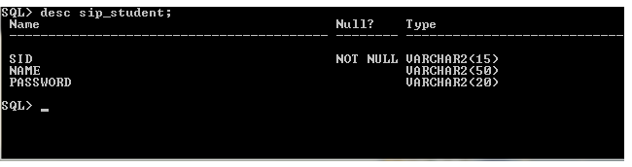

**5.3.2. sip_faculty table:**

**syntax:**

create table sip_faculty(fid varchar(15) primary key,fname varchar(50),password varchar(15));

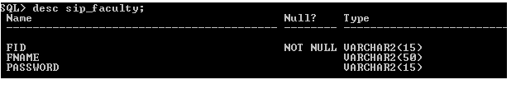

**5.3.3. class_details table:**

**syntax:**

create table class_details(aid number primary key,branch varchar(15),batch number,sem number,total_classes number);

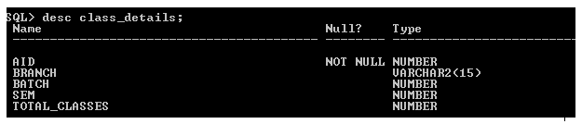

**5.3.4. attendance table:**

**syntax:**

create table attendance(sid varchar(12),aid number,stu_attendance number);

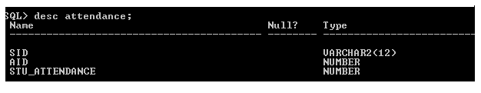

**5.3.5. test_info table:**

**syntax:**

create table test_info(tid number primary key,branch varchar(10),sem number(1),doc varchar(15),internal number(1),total_marks number(3));

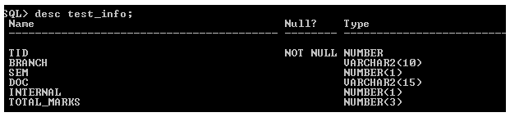

**5.3.6. sip_marks table:**

**syntax:**

create table sip_marks(sid varchar(12),tid number,marks number,subject number);

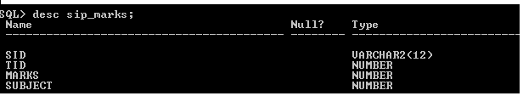

**5.4. RESULTS**

**FIG:1 HOME PAGE:**

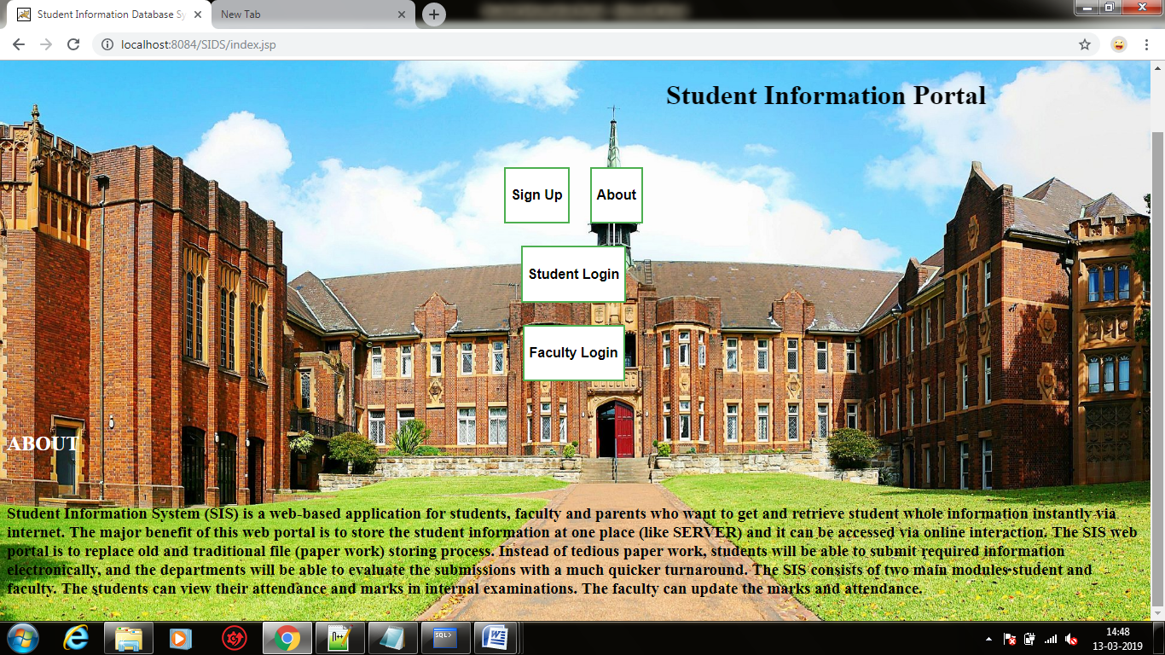

**FIG:2 SIGNUP PAGE:**

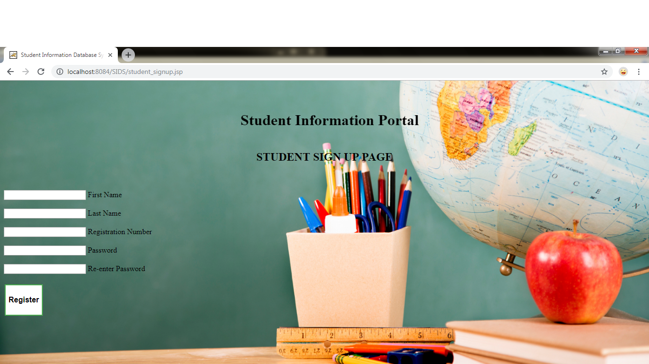

**FIG:3 STUDENT LOGIN PAGE:**

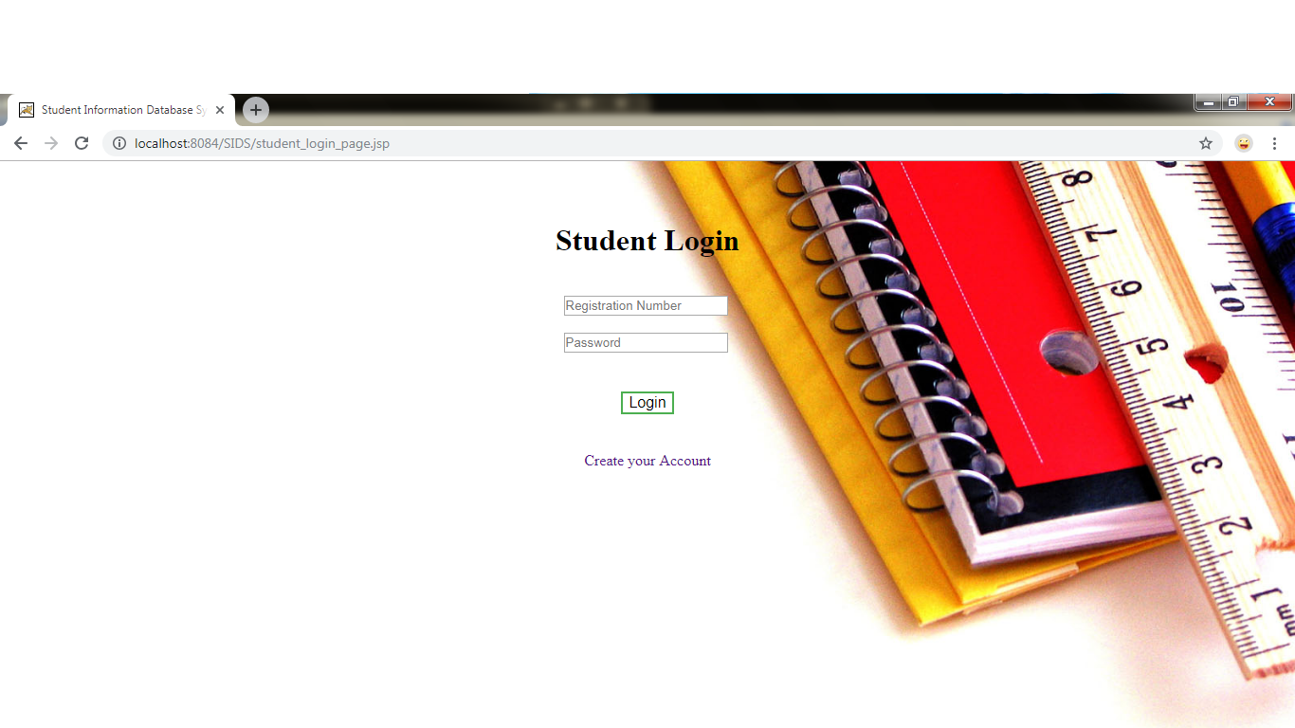

**FIG:4 STUDENT MARKS PAGE:**

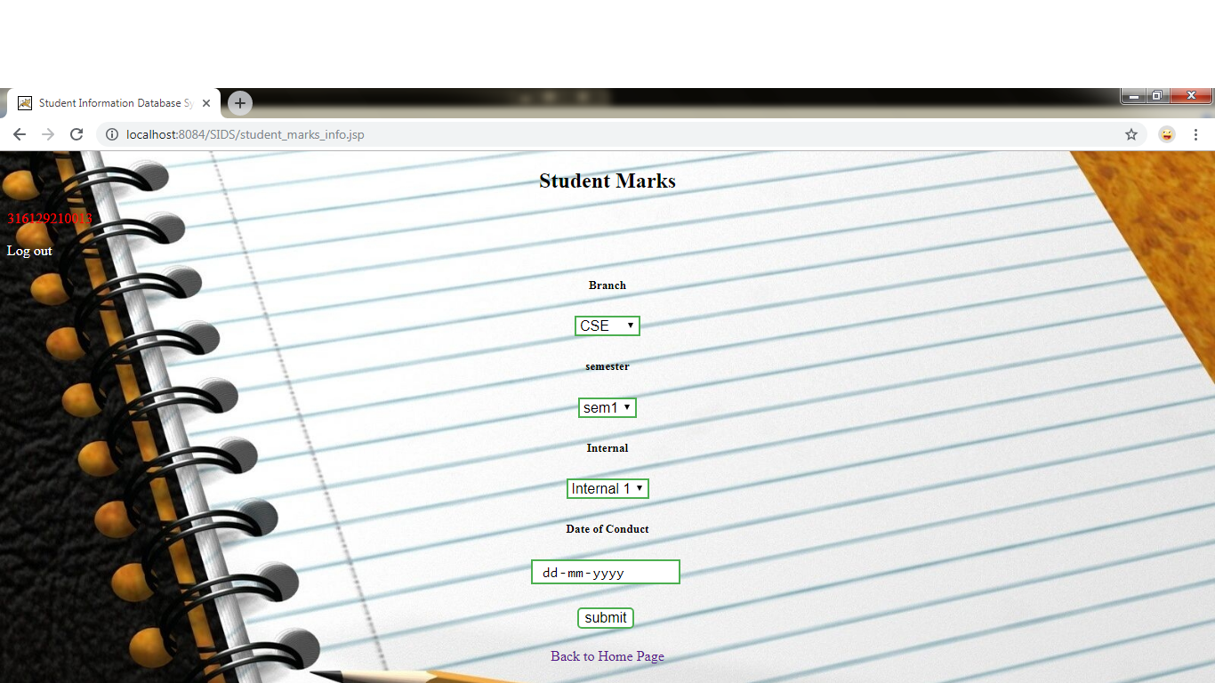

**FIG:5 MARKS DISPLAY PAGE:**

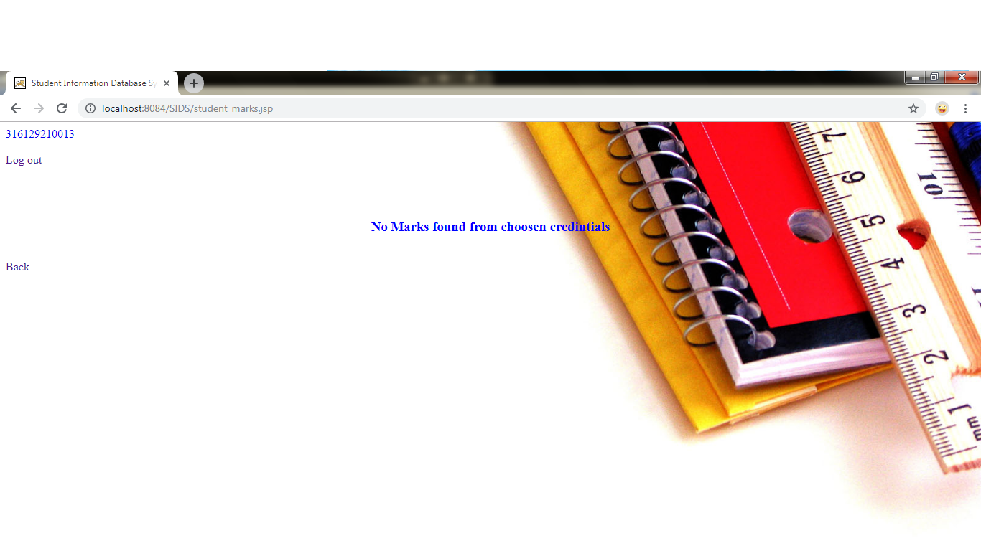

**FIG:6 STUDENT ATTENDANCE PAGE:**

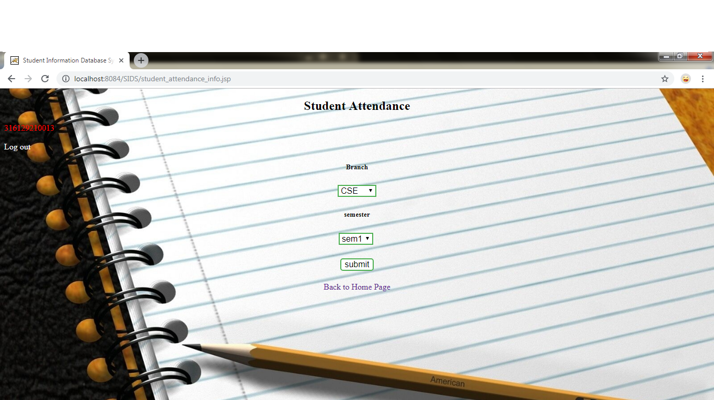

**FIG:7 ATTENDANCE DISPLAY PAGE:**

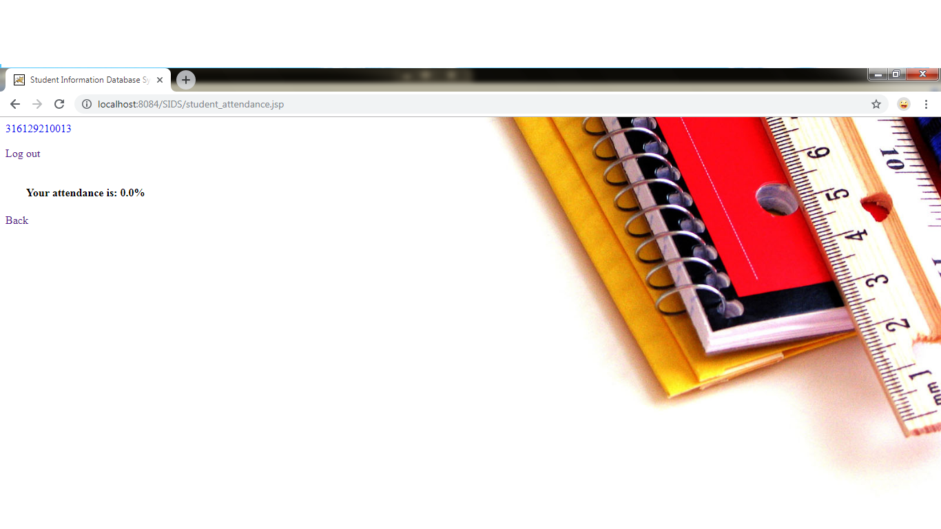

**FIG:8 FACULTY LOGIN PAGE:**

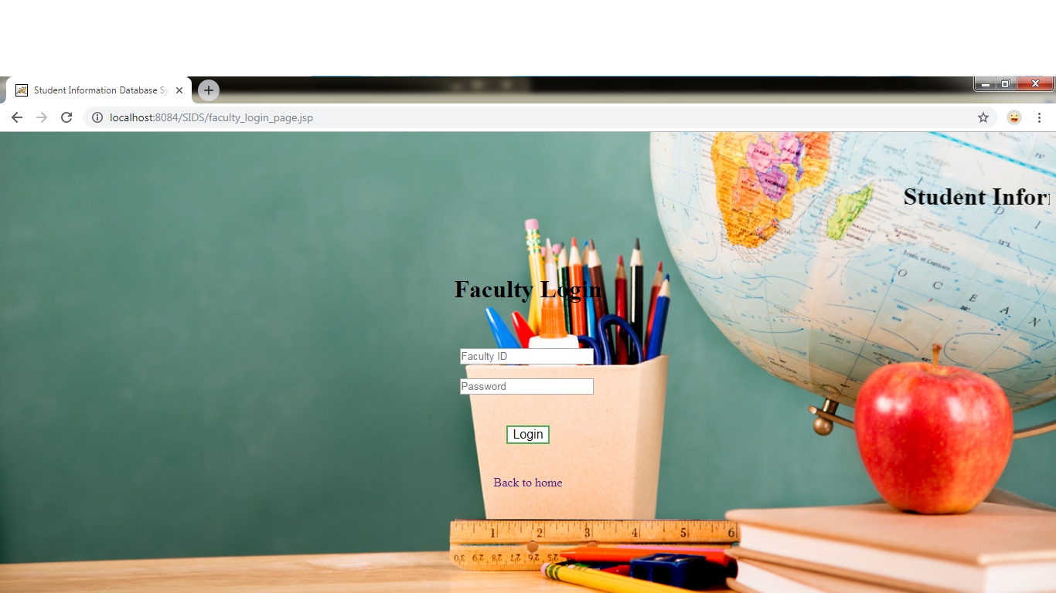

**FIG:9 WEBSITE DESCRIPTION PAGE:**

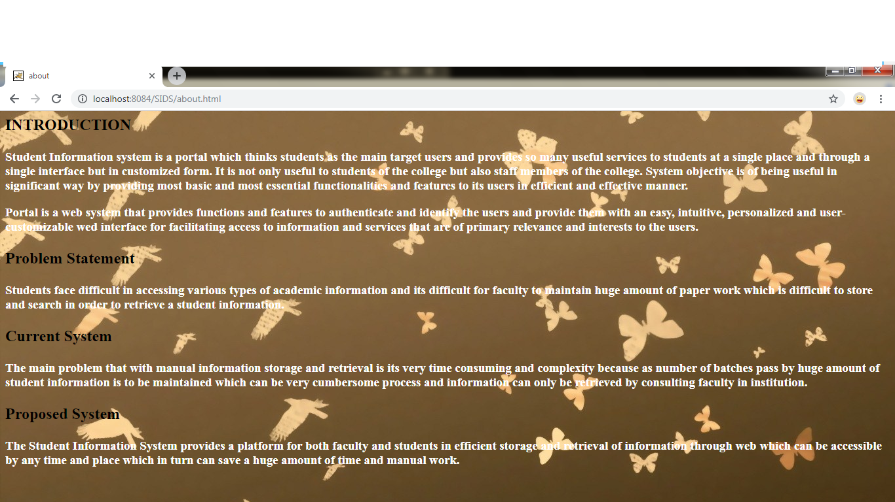

**6. CONCLUSION**

Faculty must register as admin to enter the attendance and Internal marks of student. The faculty must login to continue the above mentioned functionalities

and must provide details before filling the information and the student must register and login to continue the usage of services provided by Student Information System.

**7. Bibliography**

To create the above completed project we have referred the below given links

1. https://www.w3schools.com
2. https://www.javatpoint.com
3. https://www.quora.com
4. <https://www.colorlib.com>
5. <https://www.tutorialpoint.com>